Hi Jen,

Below is an example of the new Sales Order Confirmation Reports pulling the wrong “CDN Funds”…

The subtotals are all correct, but the end “funds” doesn’t add up:

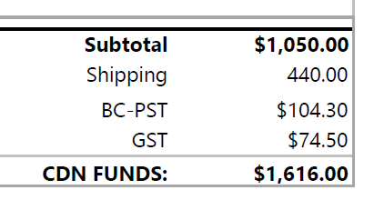
CDN Funds should be $1,050.00 + $440.00 + $104.30 + 74.50 = $1,668.80 not the posted $1,616.00

Again it seems to only be happening on Canadian Orders

Thank you,

Carter Durant  Business Development Leader  288 Don Hillock Drive  Aurora, Ontario, Canada L4G 0G9  www.cleanriver.com  T: 888-646-4246 ext. 229  D: 905-717-4989  F: 905-726-9659 | 
PRIVILEGE AND CONFIDENTIALITY NOTICE This document is intended only for the use of the individual or entity to which it is addressed and contains information that may be privileged and confidential. If the reader is not the intended recipient, employee or agent responsible for delivering the message to the intended recipient, you are hereby notified that any dissemination, distribution, copying of this communication or any action upon its contents is strictly prohibited. If you have received this message in error, please notify us immediately and delete this message.

From: Magali Fuller <magali.fuller@cleanriver.com>
Sent: Friday, December 22, 2023 8:28 AM
To: Carter Durant <carter.durant@cleanriver.com>
Subject: Total Issues on SX Orders

Hi Carter,

Using this morning’s order # S23120175 for reference:

Here is what the totals look like in the order entry screen, which is accurate:
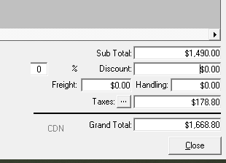

Here is the same order when the PDF order confirmation is printed, where although the subtotal, shipping and tax is accurate, the order total is not.


